**Practice Task Of Database**

|  |  |  |
| --- | --- | --- |
| **DAY 1 : Create , Insert , Alter** | | |
| **S.No** | **TASK** | **Coordinator Sign.** |
| 1. | **Create a table named PatientDetail in HospitalDB database with following columns.**   |  |  |  |  |  |  |  | | --- | --- | --- | --- | --- | --- | --- | | SR. | NAME | ADDRESS | MOBNO | ENTRY_DATE | DISCHARG_DATE | DOCTOR |   Where SR is integer and primary key and auto_increement.  NAME Should contain string type value,  Address contain string type value,  MOBNO Should contain string type value,  Entry_date should contain date type value,  Discharge_date should contain date type value,  Doctor should contain string type value.  create database hospitalDB;  use hospitalDB  create table patientDetail(  Sr int primary key identity(1,1),  NAME varchar(60),  ADDRESS varchar(70),  MOBNO bigint,  ENTRY_DATE DATE,  DISCHARGE_DATE DATE,  Doctor varchar(50)  );  insert into patientDetail values('RAM','Vikas Nagar Lucknow ',8987766554,'01-07-2021','01-07-2022','DR. Prince'),  ('SHIVAM','Cant Varanasi',NULL,'01-07-2021','01-07-2022','DR. Prince'),  ('ANURAG','Mahanagar Lucknow',8900766554,'01-07-2021','01-07-2022','Dr. Meera'),  ('MAHESH','GomtiNagar Lucknow',7987766554,'01-07-2021','01-07-2022','DR. Prince'),  ('VIKAS','Patna',8897766554,'01-07-2021','01-07-2022','Dr. Meera'); |  |
| 2. | **Insert Some Rows in PatientDetail Table as given below.**   |  |  |  |  |  |  |  | | --- | --- | --- | --- | --- | --- | --- | | **SR.** | **NAME** | **ADDRESS** | **MOBNO** | **ENTRY_DATE** | **DISCHARGE_DATE** | **DOCTOR** | | 1 | RAM | Vikas Nagar Lucknow | 8987766554 | 01-07-2021 | 01-07-2022 | DR. Prince | | 2 | SHIVAM | Cant Varanasi | NULL | 01-07-2021 | 01-07-2022 | DR. Prince | | 3 | ANURAG | Mahanagar Lucknow | 8900766554 | 01-07-2021 | 01-07-2022 | Dr. Meera | | 4 | MAHESH | GomtiNagar Lucknow | 7987766554 | 01-07-2021 | 01-07-2022 | DR. Prince | | 5 | VIKAS | Patna | 8897766554 | 01-07-2021 | 01-07-2022 | Dr. Meera | |  |
| 3. | **Create a new table named productdetails in HospitalDB with following fields.**   |  |  |  |  |  |  | | --- | --- | --- | --- | --- | --- | | SR | Product_name | Total | MRP | Salerate | Entrydate |   Where SR is integer and primary key and auto_increement.  Product_name Should contain string type value,  Total contain integer type value,  MRP should contain integer type value,  Salerate should contain integer type value,  Entrydate should contain date type value.  create table productdetails(  1. SR int primary key identity(1,1),  2. Product_name varchar(50),  3. Total int,  4. MRP int,  5. Salerate int,  6. Entrydate date  7. ); |  |
| 4. | **Insert Some Rows in productdetails Table as given below.**   |  |  |  |  |  |  | | --- | --- | --- | --- | --- | --- | | **SR** | **Product_name** | **Total** | **MRP** | **Salerate** | **Entrydate** | | 1 | [Hospital Beds](https://www.narang.com/hospital-medical-furniture/hospital-beds-icu/index.php) | 3 | 2000 | 1500 | 2021-09-01 | | 2 | [Trolley](https://www.narang.com/hospital-medical-furniture/trolley/index.php) | 2 | 3000 | 2500 | 2021-09-01 | | 3 | Injection | 1 | 200 | 150 | 2021-09-01 | | 4 | [Trolley](https://www.narang.com/hospital-medical-furniture/trolley/index.php) | 4 | 2000 | 1500 | 2021-08-01 | | 5 | [Dust Bin](https://www.narang.com/hospital-medical-furniture/dust-bin-foot-operated/index.php) | 2 | 100 | 50 | 2021-08-01 | | 6 | Injection | 6 | 300 | 250 | 2021-09-10 | |  |  |  |  |  |  | |  |
| 5. | |  |  |  |  |  |  | | --- | --- | --- | --- | --- | --- | | **SR** | **Product_name** | **Total** | **MRP** | **Salerate** | **Entrydate** | | 1 | [Hospital Beds](https://www.narang.com/hospital-medical-furniture/hospital-beds-icu/index.php) | 3 | 2000 | 1500 | 2021-09-01 | | 2 | [Trolley](https://www.narang.com/hospital-medical-furniture/trolley/index.php) | 2 | 3000 | 2500 | 2021-09-01 | | 3 | Injection | 1 | 200 | 150 | 2021-09-01 | | 4 | [Trolley](https://www.narang.com/hospital-medical-furniture/trolley/index.php) | 4 | 2000 | 1500 | 2021-08-01 | | 5 | [Dust Bin](https://www.narang.com/hospital-medical-furniture/dust-bin-foot-operated/index.php) | 2 | 100 | 50 | 2021-08-01 | | 6 | Injection | 6 | 300 | 250 | 2021-09-10 |   insert into productdetails values('Hospital Beds',3,2000,1500,'2021-09-01'),  ('Trolley',2,3000,2500,'2021-09-01'),  ('Injection',1,200,150,'2021-09-01'),  ('Trolley',4,2000,1500,'2021-08-01'),  ('Dust Bin',2,100,50,'2021-08-01'),  ('Injection',6,300,250,'2021-09-10');  **Note:** You have already created this table. Write down some SQL Query to given questions.   1. Write a SQL statement change the data type of the column MRP to string in the table **productdetails**. 2. Write a SQL Statement to change columns name **salerate** to **saleprice**. 3. Write a SQL statement to rename the table **productdetails** to **product**. 4. Write a SQL query to delete column Total from **productdetails** table. 5. Write a SQL query to add a new column named “Brand” of string type to “**productdetails**” Table. |  |
| DAY 2 : SELECT ,Delete | | |
| 2.1 | **Write a SQL Query to the given questions.**   |  |  |  |  |  |  | | --- | --- | --- | --- | --- | --- | | **SR** | **Product_name** | **Total** | **MRP** | **Salerate** | **Entrydate** | | 1 | [Hospital Beds](https://www.narang.com/hospital-medical-furniture/hospital-beds-icu/index.php) | 3 | 2000 | 1500 | 2021-09-01 | | 2 | [Trolley](https://www.narang.com/hospital-medical-furniture/trolley/index.php) | 2 | 3000 | 2500 | 2021-09-01 | | 3 | Injection | 1 | 200 | 150 | 2021-09-01 | | 4 | [Trolley](https://www.narang.com/hospital-medical-furniture/trolley/index.php) | 4 | 2000 | 1500 | 2021-08-01 | | 5 | [Dust Bin](https://www.narang.com/hospital-medical-furniture/dust-bin-foot-operated/index.php) | 2 | 100 | 50 | 2021-08-01 | | 6 | Injection | 6 | 300 | 250 | 2021-09-10 |   **Note:** Table Name (**productdeatils**)   1. Select Name, MRP of product which have highest MRP. 2. Select total MRP rate of injections. 3. Select total MRP rate of Trolley purchased in September month. 4. Select average price of trolley according to sale rate. 5. Select Name, MRP of product which have lowest MRP. 6. Calculate how many Trolley present in the hospital. |  |
| 2.2 | **Write a SQL Query to the given questions.**   |  |  |  |  |  |  |  | | --- | --- | --- | --- | --- | --- | --- | | **SR.** | **NAME** | **ADDRESS** | **MOBNO** | **ENTRY_DATE** | **DISCHARGE_DATE** | **DOCTOR** | | 1 | RAM | Vikas Nagar Lucknow | 8987766554 | 01-07-2021 | 01-07-2022 | DR. Prince | | 2 | SHIVAM | Cant Varanasi | NULL | 01-07-2021 | 01-07-2022 | DR. Prince | | 3 | ANURAG | Mahanagar Lucknow | 8900766554 | 01-07-2021 | 01-07-2022 | Dr. Meera | | 4 | MAHESH | GomtiNagar Lucknow | 7987766554 | 01-07-2021 | 01-07-2022 | DR. Prince | | 5 | VIKAS | Patna | 8897766554 | 01-07-2021 | 01-07-2022 | Dr. Meera | | 6 | MITA | Vikas Nagar Lucknow | 8987766554 | 2021-07-  03 | NULL | Dr. Prince | | 7 | GITA | NULL | 9080766554 | 2020-01-  03 | 2020-01-31 | Dr. Meera | | 8 | SIYA | Lucknow | 9876655443 | 2021-04-  02 | 2021-04-12 | Dr. Prince | | 9 | RIYA | Patna | 7889766554 | 2021-08-  05 | 2021-08-15 | Dr. Shikha | | 10 | Sandeep | NULL | NULL | 2021-05-  05 | 2021-05-15 | Dr. Rajendra | | 11 | Mukul | Patna | NULL | 2021-09-  01 | 2021-09-06 | Dr. Prince | | 12 | Mukesh | BHU  Varanasi | 7654345667 | 2021-10-  23 | 2021-10-31 | Dr. Shikha |   **Note :**Table Name (**PatientDetail**)   1. Select list of patient whose name starts from S. 2. Select details of patient who admitted in September month. 3. Select details of patient whose mobno starts from 7. 4. Select list of patient who is admitted in under of Dr. Prince. 5. Select name, address of those patient who belong to Lucknow city. 6. Select all detail of patient whose city is Patna and doctor is DR. Prince. 7. Select all patients of Patna and Lucknow. 8. Select all patient list who belongs to Patna and admitted in September month. 9. Delete all patient details of Dr. Prince from table. |  |
| 2.3 | Create a table as given below and insert data as described below.   |  |  |  |  |  | | --- | --- | --- | --- | --- | | EMPLOYEE_ID | FIRST_NAME | HIRE_DATE | JOB_ID | SALARY | | 100 | Siya | 2012-06-06 | IT_PROG | 50000 | | 101 | Satyam | 2017-08-09 | SOFT_PROG | 20000 | | 102 | Saurabh | 2019-09-15 | IT_PROG | 100000 | | 103 | Seema | 2012-06-06 | IT_PROG | 80000 | | 104 | Shivam | 2019-08-15 | IT_PROG | 200000 | | 105 | Sandhya | null | SOFT_PROG | 100000 | | 106 | Shakshi | 2021-09-25 | SOFT_PROG | 200000 | | 107 | Shilpa | null | SOFT_PROG | 60000 | | 108 | Shubham | 2019-08-15 | IT_PROG | 33000 |   NOTE:- EMPLOYEE_ID is integer and primary key and auto_increement.  FIRST_NAME Should contain string type value,  HIRE_DATE contain date type value,  JOB_ID should contain string type value,  SALARY should contain integer type value.   1. Select record of employee who earns more than 40000. 2. Show name and job_id of those employees who joined company before 2018-01-01. 3. Show all record of employee whose job_id IT_PROG and salary is greater than 100000. 4. Select all record of employee whose JOB_ID is either IT_PROG or who joined company after 2017-01-01. 5. Select record of employee whose salary is under 20000-100000. 6. Select all employee details whose name starts with ‘Sh’. 7. Select number of employee whose HIRE_DATE is null. 8. Delete record of employee whose salary is less than 33000. 9. Delete all record of employee whose JOB_ID is either IT_PROG or who joined company after 2017-01-01. 10. Delete record of employee whose salary is belongs to 20000-60000 or HIRE_DATE is null. |  |
| DAY 3 : Update, Drop, Truncate, Rename | | |
| 3.1 | SQL Query Interview Questions  **Note : Table Name (Employee)**   1. Update all employee salary is equals to 50000 whose salary is less than 100000.      1. Write a SQL Query to rename Employee table to Employees_Details. 2. Write down SQL Query to truncate all records. 3. Write down SQL Query to drop table Employee. 4. Update all employee department whose first_name starts with J. |  |
| 3.2 | **Note : Table Name (Customer_Details)**   1. Write a SQL Query to change table name Customer_Details to new table(Customer) .      1. Write a syntax to update name whose belongs to London and Customer Age Between 18-20. 2. How to all row delete at a time write a syntax. 3. Write a syntax to drop table Customer_Details. |  |

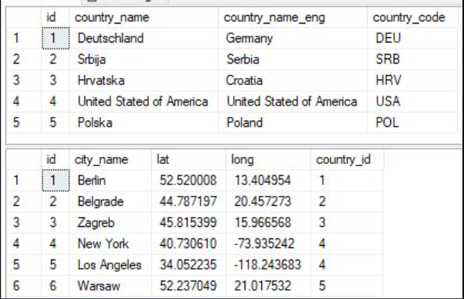Create 2 Tables named tbl_Country and tbl_city with following data

Create a table as given below

SN is integer and Auto increment

First_name and last_name is NOT NULL Type

Email id is primary key

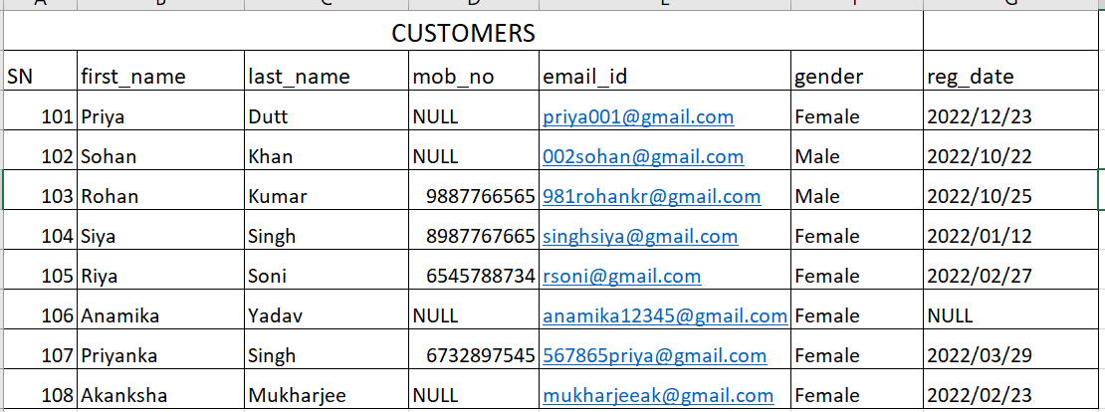

Create a table named Order

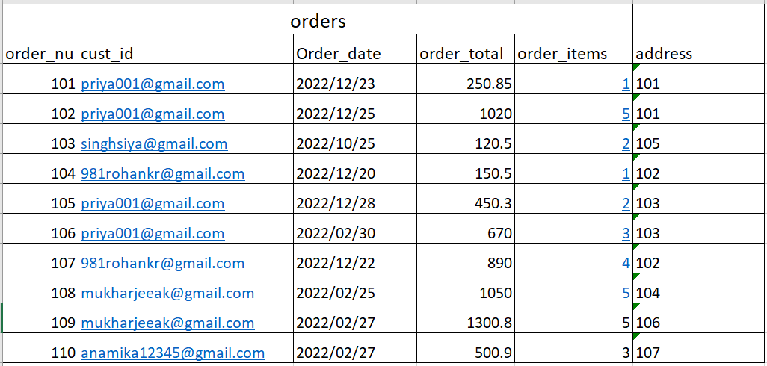

Create a table named address

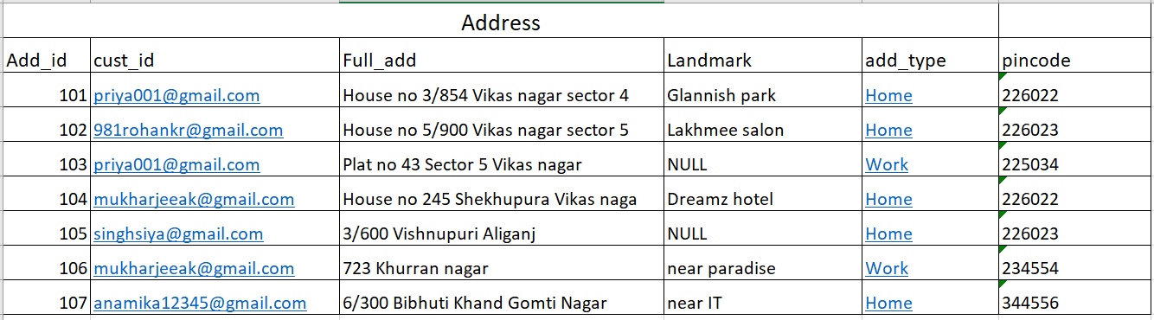

1. Select all record stored in table customers.

Ans : select * from customers;

1. Select only first_name, last_name, email_id of all customers

Ans. select first_name,last_name,email_id from Customers;

1. Select all records of those customers who has no mobile number

Ans: select * from Customers where mob_no is null;

1. Select all customer records in ascending order of first_name and last_name

Ans: select * from Customers order by first_name ,last_name asc;

5. Select those customer records who registered in october month

Ans: select * from Customers where reg_date like'_____10%';

Select total items sold February month

Ans: select sum(order_items) from orders where order_date like'_____02%'

2. Select total purchase amount of Priya dutt.

Ans: select sum(order_total) from orders where cust_id='priya001@gmail.com';

3. Select all order details where total amount is greater than 1000.

Ans: select * from orders where order_total>1000;

4.Select all order details where purchase amount is within 500 to 1500.

Ans: select * from orders where order_total between 500 and 1500;

1. Select all order details where purchase amount is within 500 to 1500 of Priya, Rohan and Siya.

Ans:

6. Select order details of all customers with one more column named order_type .

If total purchase items is less than 3 then show less quantity otherwise show good quantity

7. Select orders of all customers except priya